A1. a:
01000001 00001000 00000000 00000000
0x41080000

b:
11000001110010100000000000000000
0xC1CA0000

c:
2,27

d:
-1.

A2a:
Q = ABC + C + B + A * C

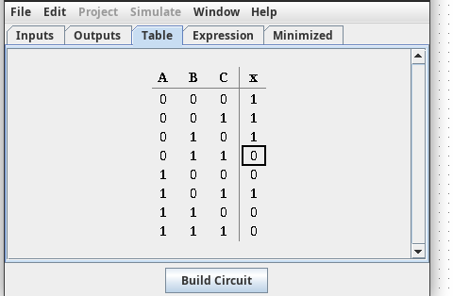
b:

c:
K[Q] = 3 + 1 + 1 + 2 = 7
d:

A/BC | 00 | 01 | 11 | 10
0 | 1 | 1 | 0 | 1
1 | 0 | 1 | 0 | 0
Q’ = A * C + B * C
e:
K[Q’] = 2 + 2 = 4
F:
Q’ = A * C + B * C

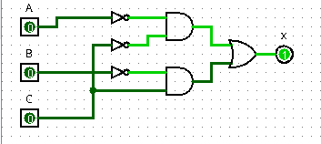
A3A:
Q = D + B * D + A + A * D + A * B + A * B * D
B:

K[Q] = 1 + 2 + 1 + 2 + 2 + 3 = 11
C:
AB/CD | 00 | 01 | 11 | 10
00 | 0 | 1 | 0 | 0
01 | 0 | 1 | 0 | 0
11 | 1 | 1 | 0 | 0
10 | 1 | 1 | 0 | 0

Q’ = D + C + B * D

D:
K[Q’] = 1 + 1 + 2 = 4

E:
Volgens Logisim is de geminimaliseerde vergelijking: C * D + A * C
Deze vergelijking klopt geloof ik.

